|  |
| --- |
| **RiKU kingdom studios** |
| **Insert a Company Logo here**  2D CAT PLATFORM |
| **[CAT PLATFORM]** |
| Version #2  All work Copyright © 2016 by Riku kingdom studios.  All rights reserved. |
| **[Ranjana Kalra]** |
|  |

**Table of Content**

|  |
| --- |
| Oct 3 2016 |

**I.** **Game Overview** 4

**II.** **Game Play Mechanics** 4

**III.** **Controls** 4\

**IV.** **Interface Sketch** 4

**V.** **Menu and Screen Descriptions** 4

**VI.** **Game World** 6

**VII.** **Characters** 6

**VIII.** **Non-player Characters** 6

**IX.** **Enemies** 6

**X.** **Scoring** 7

**XI.** **Sound Index** 7

**XII.** **Story Index** 7

**XIII.** **Art / Multimedia Index** 7

Player cat in the game. 7

Coins, for the purpose to get score. 7

Dog, the enemy in the game. 7

1. **Game Overview**

The player in this game is cat which has to avoid colliding with the dog in the game so as to save its lives. The lives count from 5 to 0 which decreases each time the cat collides with the dog.

Along with this, there is another cat named cat in the game which is designed to increase the points for the player cat, whenever it grabs cat.The final score is shown at the end of the game, that means when the lives reaches zero.

1. **Game Play Mechanics**

The game starts with a cat which is the player in the game. This cat can move up and down with the help of arrow keys so as to avoid collision with the dog, which is the enemy in this game and this lives counter decrease when the player cat collides with the enemy. At the end of these lives, the game will be over and also, to collide with another small cat. With this, the player is going to increase its score.

1. **Controls**

The game player is controlled with the help of the WASD keys. The cat moves up and down with the use of up and down direction key.

1. **Interface Sketch**

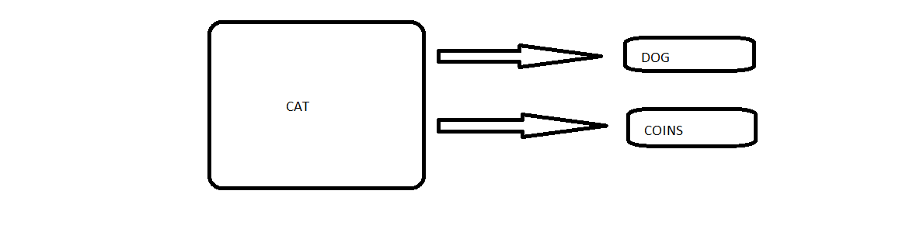

1. **Menu and Screen Descriptions**

At the end of the game, you can see the final score, the player has achieved. Also, a button named as RESTART BUTTON can be seen there so as to restart the game.

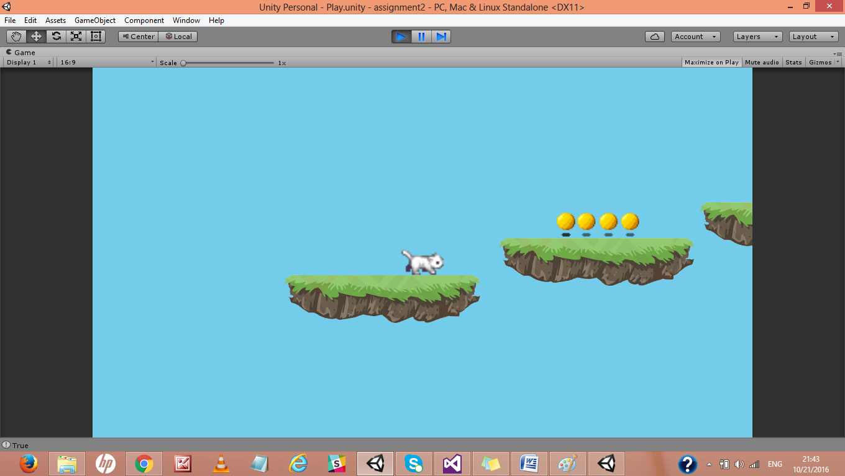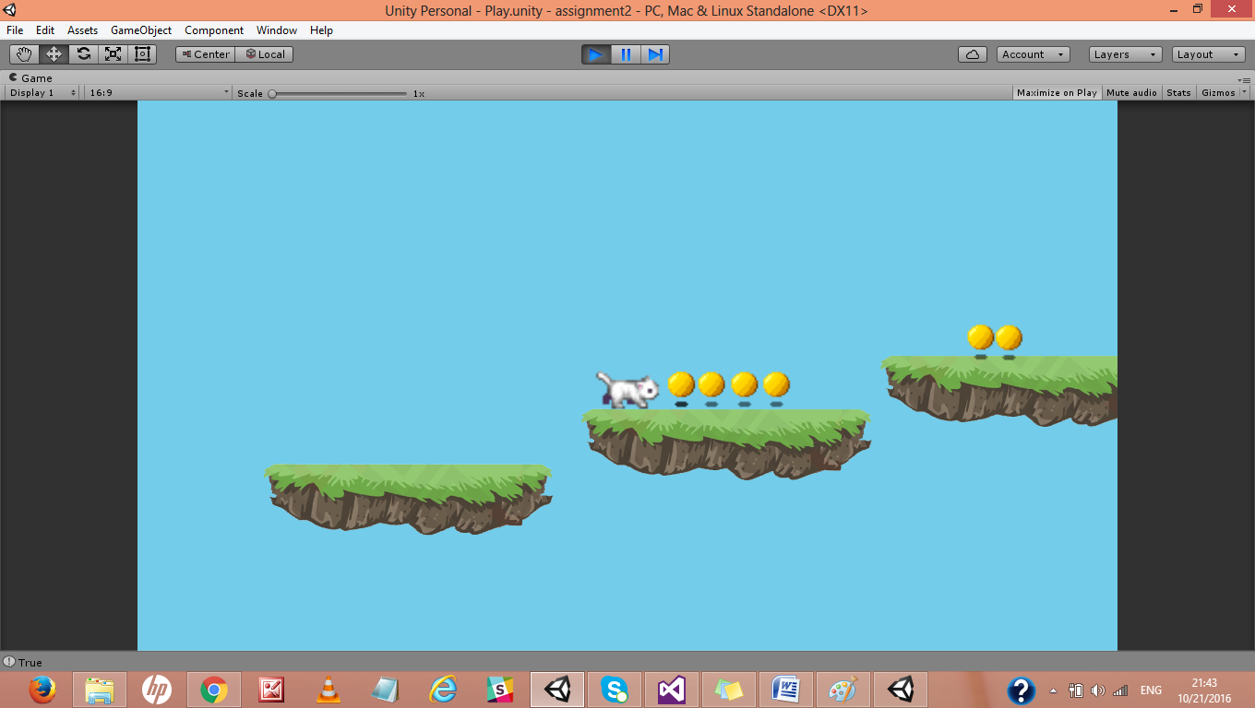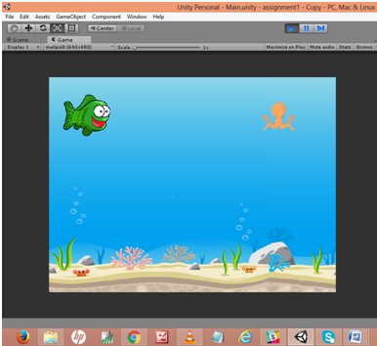

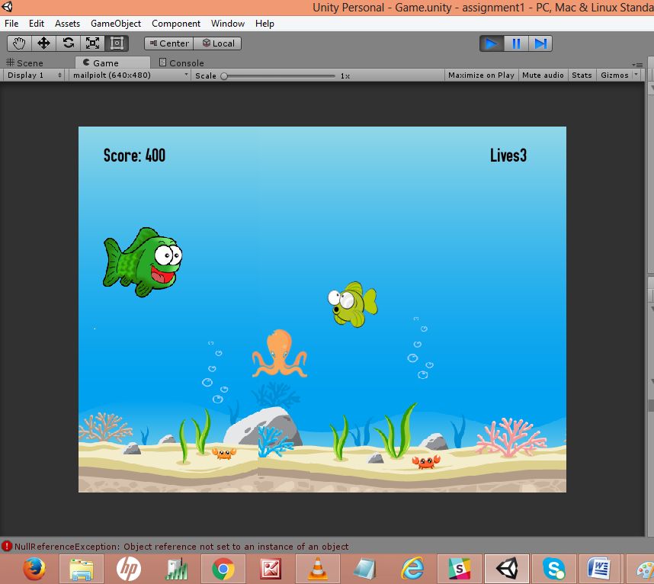

1. **Game World**

The game world here is an ocean where we can see the aquatic animals like cates and dog as the player and enemy in the game. The background shows the scene of an ocean.

1. **Characters**

The main character in the game is CAT1, which is the player in the game. Along with this, the enemy of this player is DOG which is to be avoided so as to save the lives of the player. Including to this, there is another character COINS which is to be collided so as to get the scores.

1. **Non-player Characters**

In this game, the enemy that is the DOG and the COINS is controlled by the computer coding, including its occurrence and the speed.

1. **Enemies**

Here in this game, the enemy of the player cat is, dog, that has to be avoided so as to save lives.

1. **Scoring**

It is accomplished by colliding CAT1 with COINS. So, whenever player cat collide with another cat, each time it gets 100 score. And each time it collides with dog, it losses 1 life.

1. **Sound Index**

The game includes sound effects at each level of collision. The game gives a particular sound on collision of player cat and dog, while another sound effect on collision of the two cats. After that, there is another sound that can be heart at the end of the game.

1. **Story Index**

The game story includes that in an ocean, a cat which is the player in the game, moves on in the ocean and collides with another cat to get the score. On the other, it has to avoid dog, the enemies in the game.

1. **Art / Multimedia Index**

**G:\gaming\assignment2\Assets\Sprites\hero\catrecolors.png**

Player cat in the game.

C:\Users\hp\AppData\Local\Microsoft\Windows\Temporary Internet Files\Content.Word\tjrkrQ7.png

Coins, for the purpose to get score.

C:\Users\hp\AppData\Local\Microsoft\Windows\Temporary Internet Files\Content.Word\catrecolors.png

Dog, the enemy in the game.